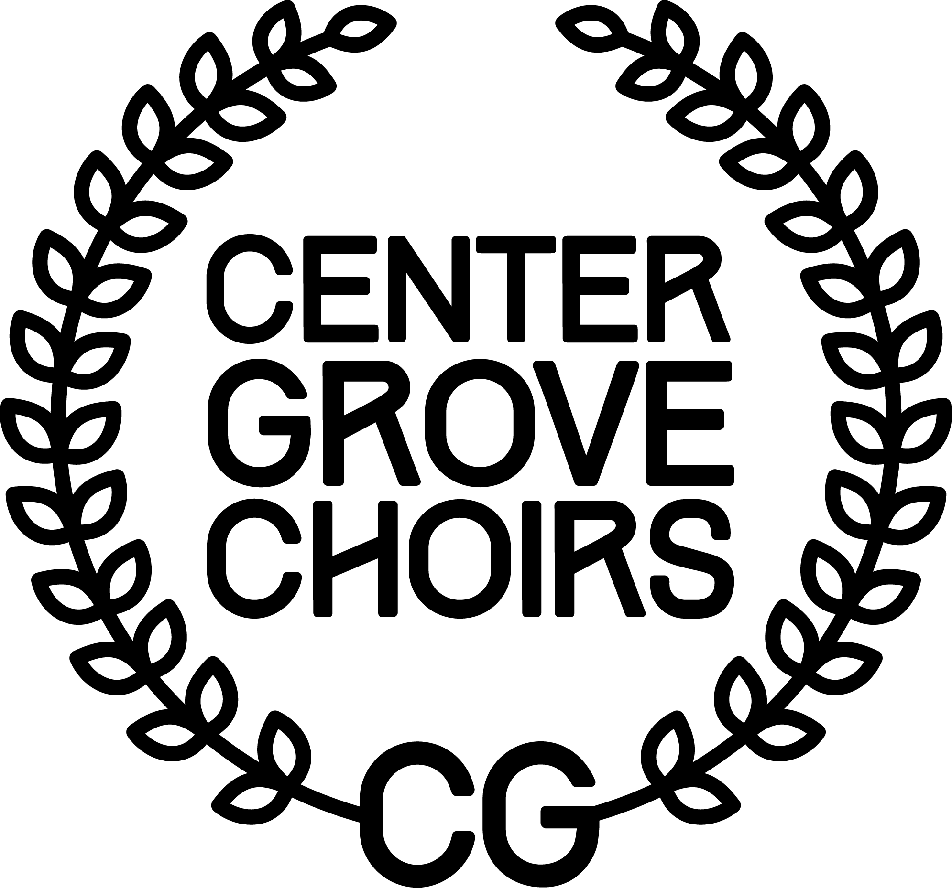

CENTER GROVE CHOIR PARENT ORGANIZATION
SCHOLARSHIP APPLICATION

The Center Grove Choir Parent Organization will award a non-renewable $1000 scholarship to a graduating Center Grove senior who has participated a minimum of two years in the Choral Department, has shown outstanding commitment to the Choral Department, and has maintained academic excellence. The scholarship may be divided into two $500 scholarships if the selection committee deems that there should be two recipients. The award will be paid directly to the college or trade school of the student’s choice. An impartial selection committee will choose the recipient of the scholarship. To apply for this scholarship, complete the following application and essay and return to the guidance office by:

Monday, Apr. 27, 2026

Student Name
Years in CGHS Choirs
Post-Graduate Plans
Have you been accepted to school?
Intended Major- please indicate if you have been accepted to this major

(To be completed by guidance office)

Applicant’s Class Rank
Applicant’s GPA

ESSAY (required for consideration):
Please attach an essay explaining your reasons for seeking this scholarship and how you have contributed to the choral program. You may also list any other musical activities, your extra-curricular activities (including community involvement), and jobs held.

Thank you for your participation in the Center Grove High School Choral Department!

