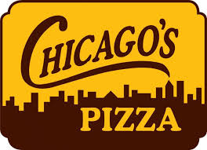
Chicago’s Pizza Fundraiser
Credit to Individual Accounts and CG Choirs

This is an awesome and SUPER easy fundraiser!
Everyone eats pizza!
- We will run this fundraiser multiple times this school year – approx. once each of the remaining grading periods.
- Sales begin on Wednesday, August 11th and run until Wednesday, August 25th.
- Pizza cards are good for ONE LARGE 1-TOPPING PIZZA and will be sold for $13 each (this is $1.50 less that it costs to buy one there)
- You will collect money as you take orders. You will write ONE CHECK for your orders and turn in the bottom of this paper ONLY.
- Your student will receive $4 choir account credit for each card sold, and choir will receive $1 for each card sold.
- Order forms and money need to be in the white choir box by the end of the school day on Wednesday, August 25th.
- Pizza cards will be sent home the week after orders are due.
-----------------------------------------------------------------------------------------------------------
Student Name______________________ Choir__________________
# of Cards needed___________x $13 = _____________________total enclosed in envelope

Chicago’s Pizza Fundraiser
Order Form
FOR YOUR RECORDS – DO NOT TURN THIS IN
Name | # of cards | Total Due |  | Name | # of cards | Total Due
TOTAL |  |  |  | TOTAL

